**Exercise: Plotting Weather Data**

Produce the following graph using the data from this Excel file: <https://github.com/pythonizing/data/raw/master/verlegenhuken.xlsx>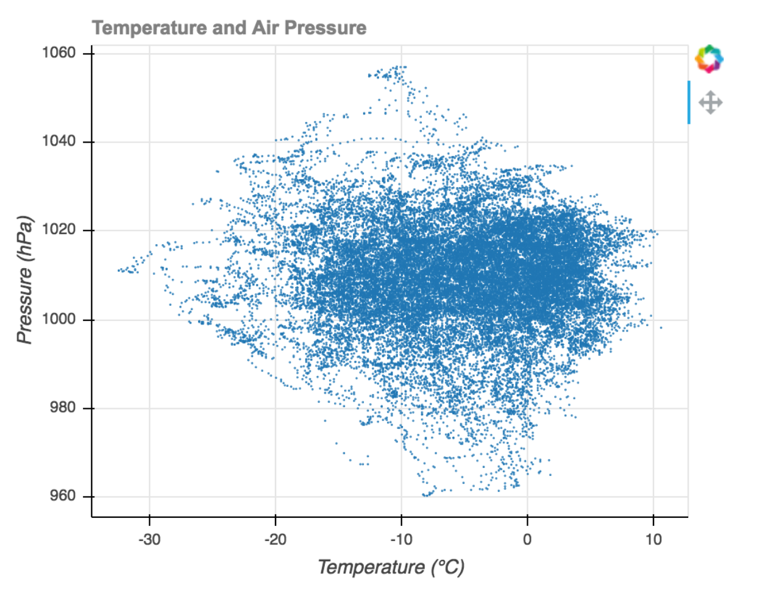

*Some notes:*

Temperature and pressure values in the Excel file have a scale factor of 10; you'll have to divide those values by 10 to get the actual observations.

And, yes, you can set your own fonts and colors but be accurate with the rest of the plot elements.